LED – Light- emitting diode, a semiconductor diode that glows when a voltage is applied.
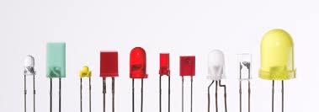
Photocell- a solid-state device that converts light into electrical energy by producing a voltage, as in a photovoltaic cell, or uses light to regulate the flow of current, as in a photoconductive cell.
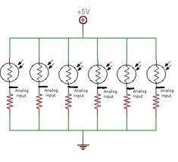
Potentiometer- an instrument for measuring an electromotive force by balancing it against the potential difference produced by passing a known current through a known variable resistance.
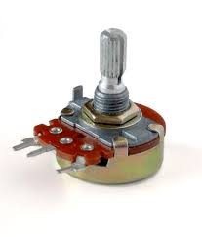
DC motor- is a mechanically commutated electric motor powered from direct current.
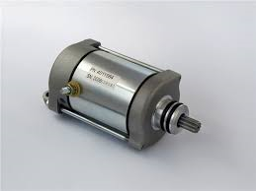

Stepper motor- is a brushless DC electric motor that divides a full rotation into a number of equal steps.
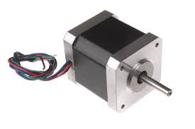
AC power- is an electric motor driven by an alternating current.
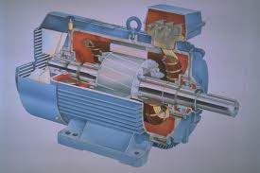

DC power- is the unidirectional flow of electric charge.
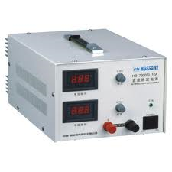

Infrared sensor - is an electronic device that emits or detects infrared radiation to sense aspects of its surroundings.
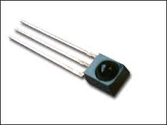

Electron - a stable subatomic particle with a charge of negative electricity, found in all atoms and acting as the primary carrier of electricity in solids.
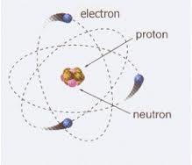

Neutron- a subatomic particle of about the same mass as a proton but without an electric charge, present in all atomic nuclei except those of ordinary hydrogen.
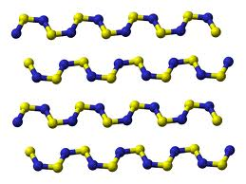

Proton - a stable subatomic particle occurring in all atomic nuclei, with a positive electric charge equal in magnitude to that of an electron, but of opposite sign.
