Wire - 

Connecting wire and unconnected wire - 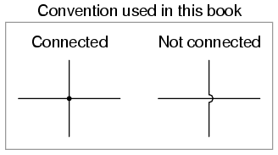

Branched wire - 

Motor -   
Push button switch - 

Cell - 

Battery - 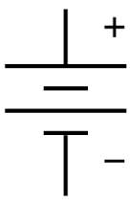

Resistor -  

Capacity - 

Inductors - 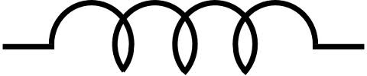

Diodes - 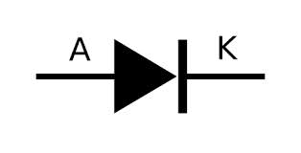

LED - 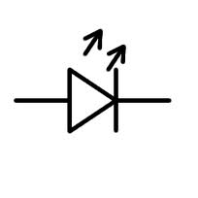

Transistor - 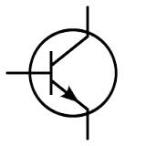

Switch - 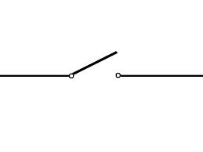

Light - 

Direction of current flow - 