Power & Energy 3201
Engine Disassembly Instructions
206cc Briggs & Stratton 875 INTEK Series Engine
Model: 120000
NOTE: Does NOT contain disassembly instructions for cylinder and carburetor.
Name: Brittany & Danica
- Remove the oil drain plug using a 10mm crescent wrench and drain the oil from the crankcase/base into a suitable container. Removing the oil level indicator (dipstick) will let the oil flow out faster. Screw the drain plug back into the crankcase/base after the oil is completely drained.
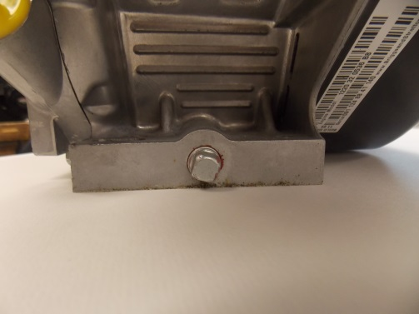
- Remove all fuel from the fuel tank and store in an appropriate container.
- Turn fuel shut off switch to OFF
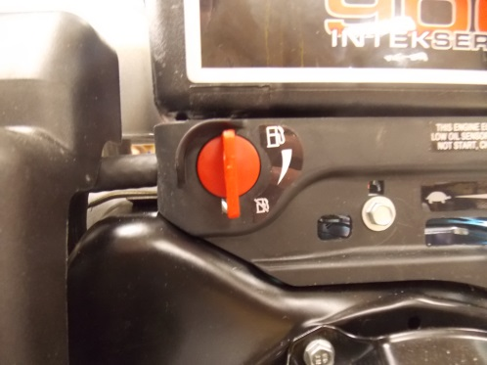
- Remove the spark plug wire cap from the spark plug.
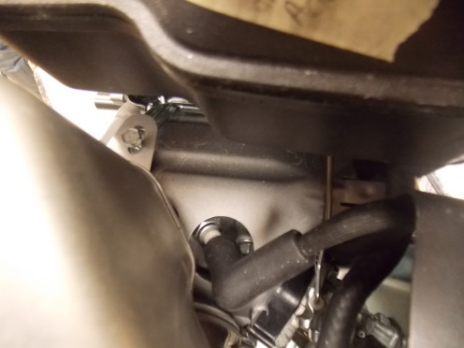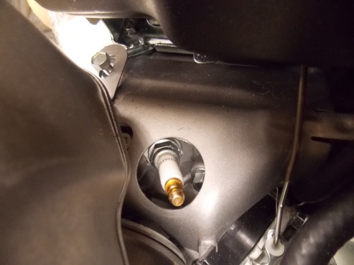
- Remove the plastic air cleaner/filter cover using a flat top screw driver or 8mm wrench or socket.
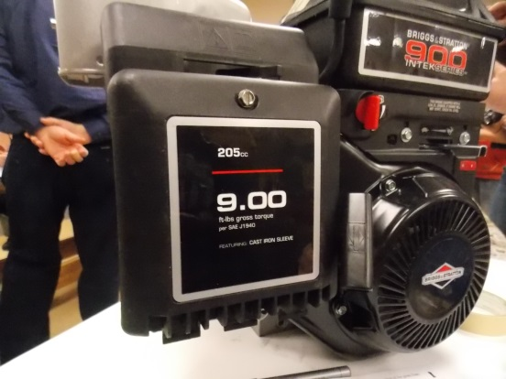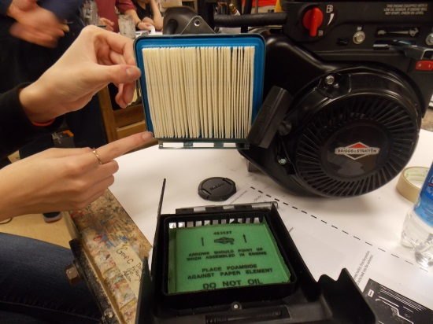
- Move the choke lever to the closed position to prevent dirt from entering the carburetor.
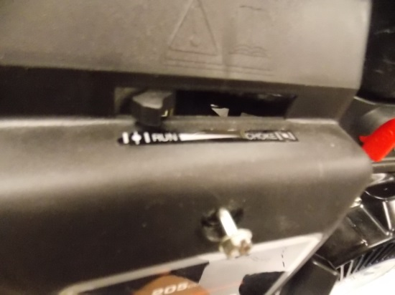
- Remove the 2 bolts attaching back plate from the carburetor using a 7mm wrench. Note the position of the gasket between the back plate and the carburetor. Reattach the 2 bolts back into the carburetor.(you don’t need to turn the bolts all the way in)
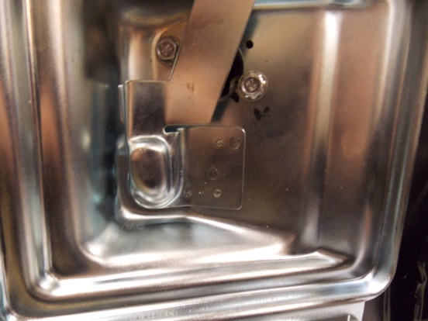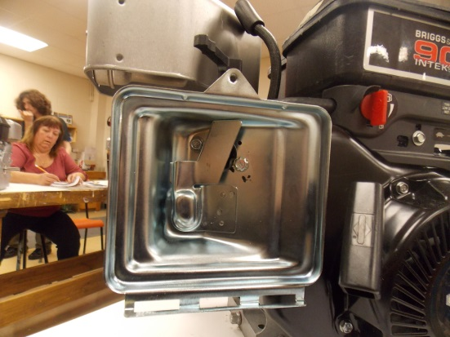
- Remove the black air line from the back of the plate.
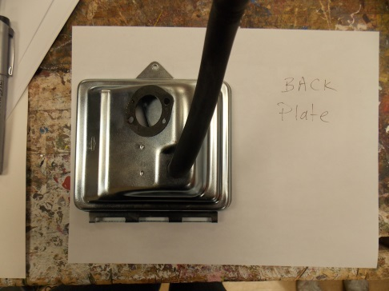
- Remove the 4 screws and the bolt attaching the exhaust/muffler heat shield using a 7mm wrench or socket. Remove the screws and bolt with a 10mm wrench or socket.
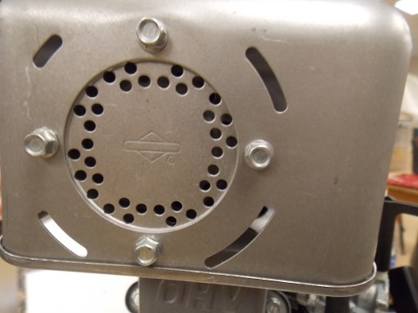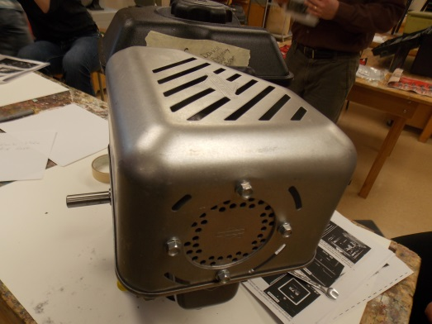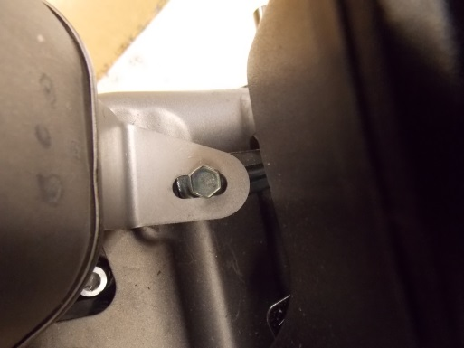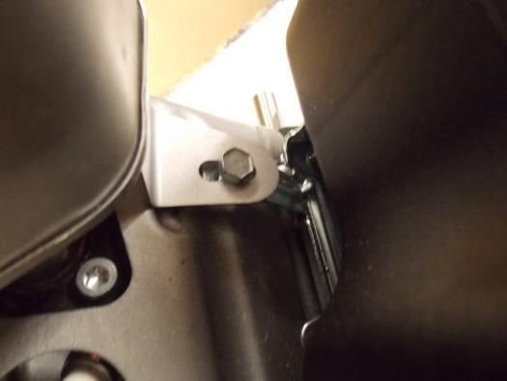
- Remove the 2 bolts attaching the muffler using a 10mm wrench or torque socket. Note the position of the gasket between the muffler and the cylinder head. Reattach the bolt to the cylinder. Be careful NOT to lose them into the cylinder head.
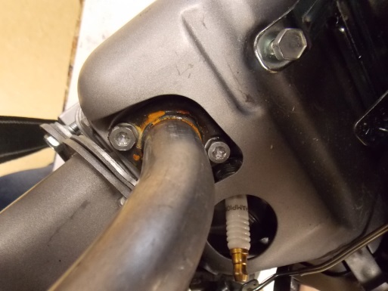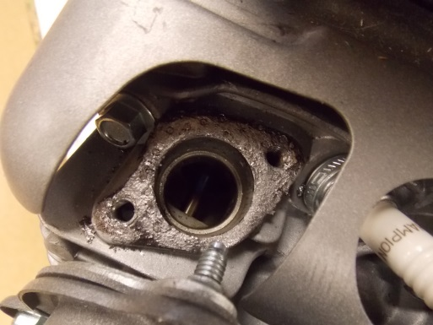
- Remove the 4 bolts from the recoil starter using an 8mm wrench or socket. Re-attach the 4 bolts to the flywheel cover.
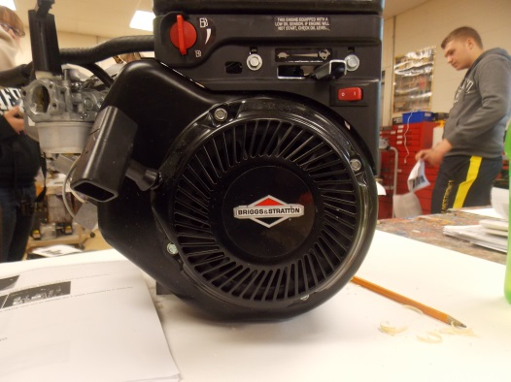
- Move the speed control lever to the middle position. Remove the 3 bolts from the plastic fuel shutoff/speed control/ignition switch cover using an 8mm wrench or socket.
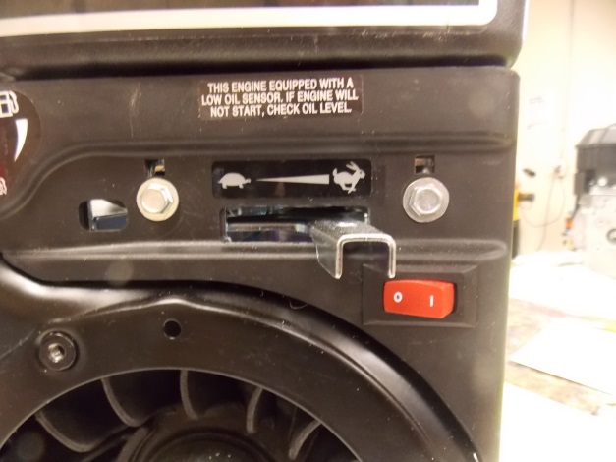
- CAREFULLY remove the plastic cover taking care not to damage the 3 wires connecting to it. Note the position of each colour wire.
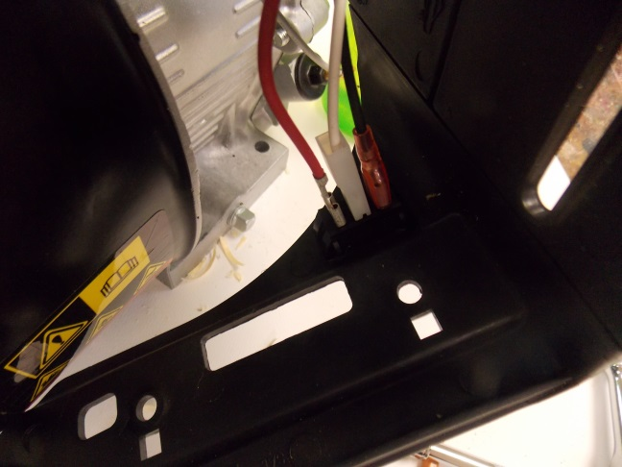
- Disconnect the 3 wires using pliers to GENTLY remove the three wires.
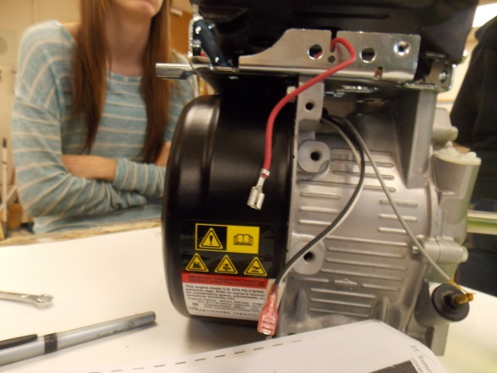
- Screw 3 bolts back in.
- Remove the bolt attaching sensor relay using a 10 mm wrench or socket.
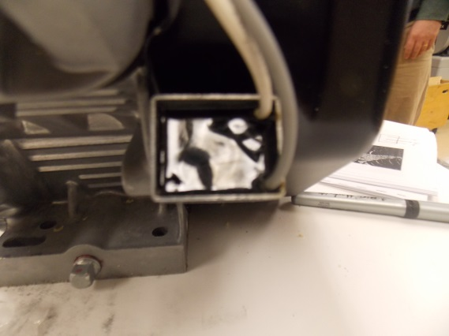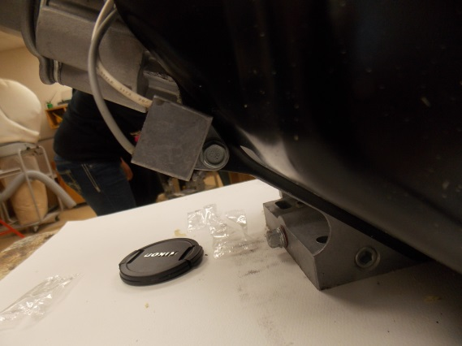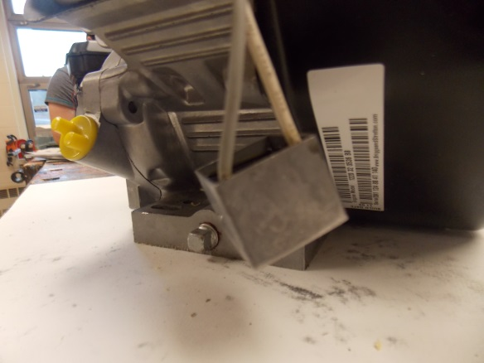
- Remove the remaining 3 bolts connecting the wheel cover to the engine block using a 10 mm wrench or socket.
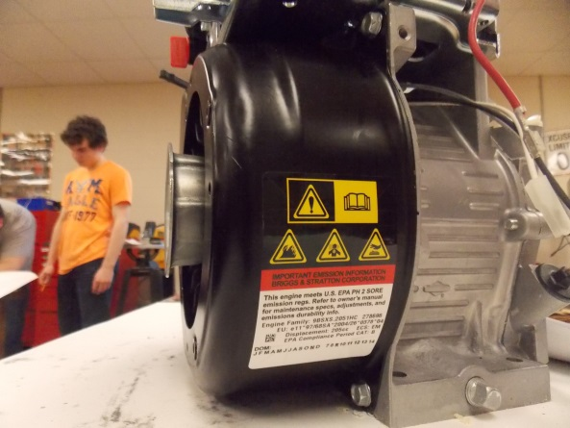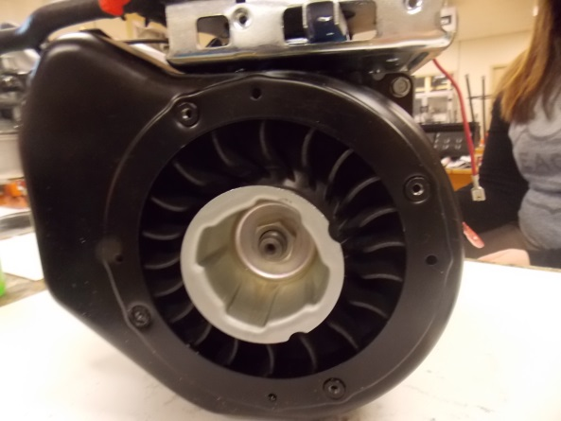
- Remove the 4 bolts attaching the gas tank using a 10mm wrench or socket. Remove fuel line from gas tank using pliers on clamp.
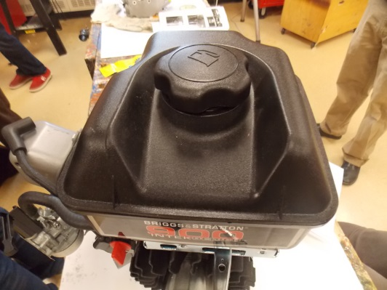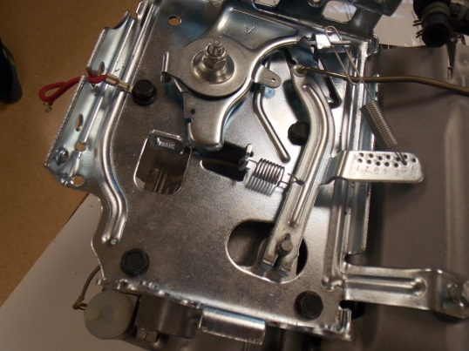
- Remove the fuel line from the carburetor using pliers. Put the bolts attaching the fuel tank back into the frame.
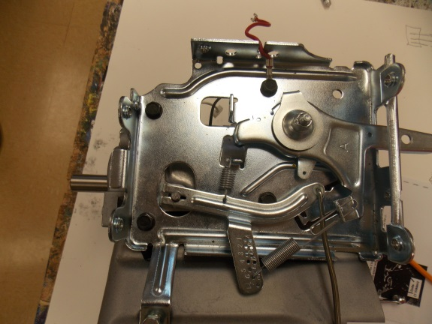
- Carefully remove the 2 bolts attaching the carburetor using a 10mm socket or wrench. Note the positions of the gaskets and spacer which fit between the carburetor and the cylinder.
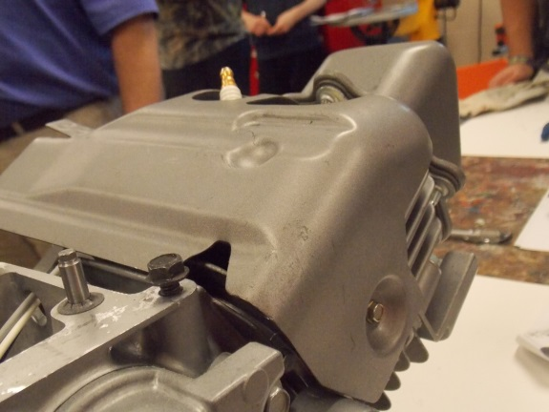
- VERY carefully remove the linkage and the spring attached to the carburetor.
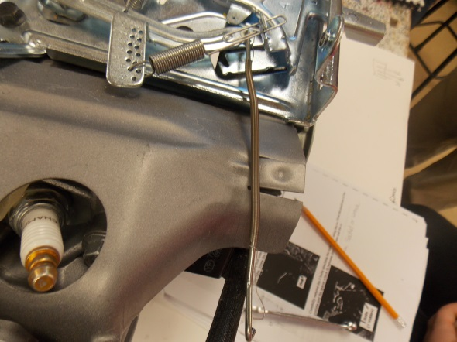
- Screw the 2 bolts attaching the carburetor back into the cylinder head.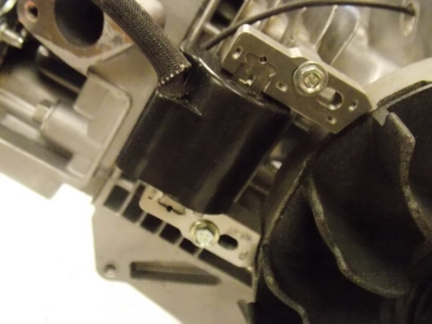
- Note the position and orientation of governor spring and carefully remove the end attached to the speed control lever.
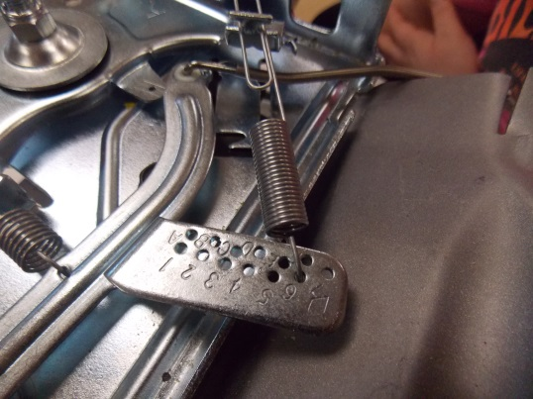
- Note the orientation of the second spring and remove it from the governor lever using a 10mm wrench or socket.
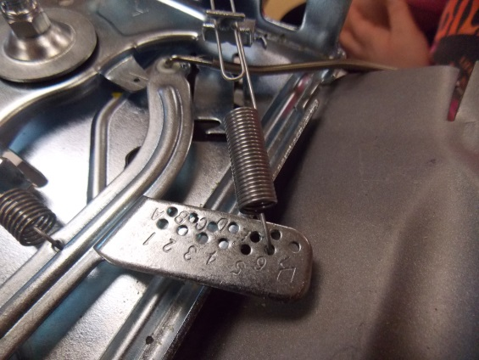
- Loosen the nut that secures the end of the governor lever to the post attached to the frame using a 10mm wrench or socket. Note the position of the shaft on the post.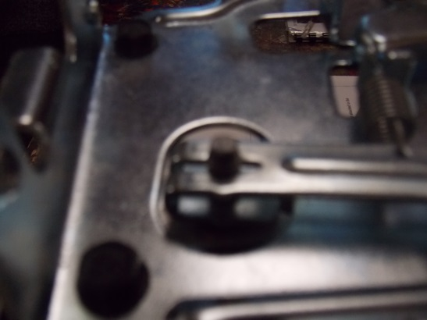
- Gently enlarge the spacing on the end of the lever with pliers and remove the lever from the shaft.
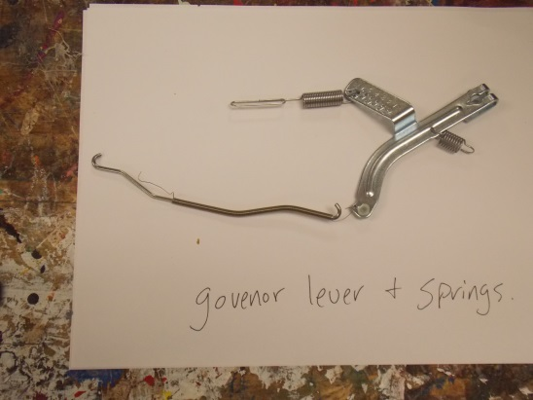
- Remove the 4 bolts attaching the frame to cylinder using the correct tool. Note the position of the red grounding wire. Screw the 4 bolts back into the engine block with the red ground wire on the correct bolt.
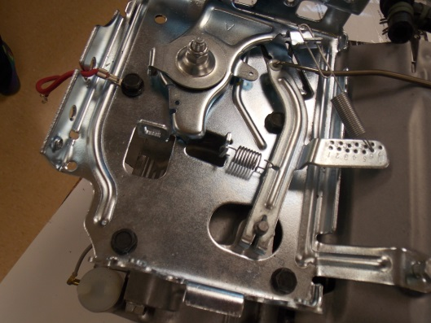
- Remove the bolt attaching the heat shield between the cylinder head/cylinder and the engine frame using a 7mm socket or wrench. Screw the bolt back into the cylinder.
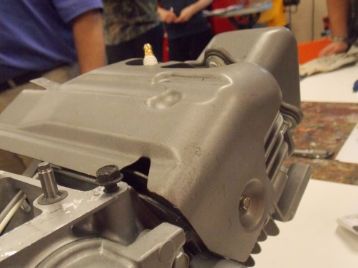
- Remove the flywheel nut and cup using fly wheel holder. Pull off the plastic flywheel fins. Gently pry off flywheel fin with pry bar. Use pipe extensions for leverage on flywheel holder and socket when removing flywheel from new engine.
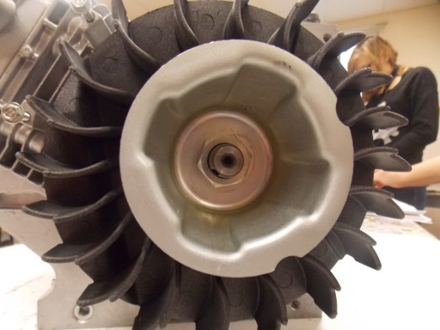
- Remove the gray wire from the oil level sensor; no tools are needed to remove the wire. Remove the oil sensor relay.
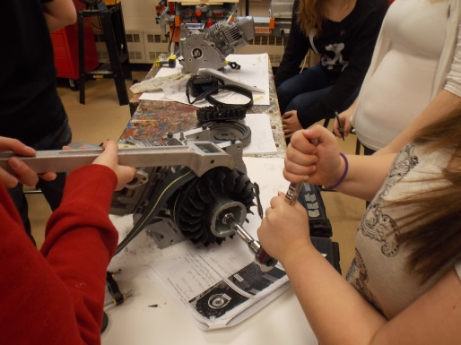
- Remove the 2 bolts attaching the ignition armature (coil) using a 7mm socket or wrench.
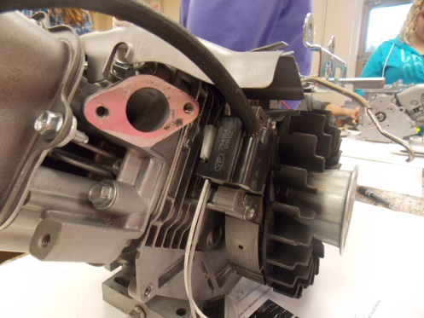
- Remove the flywheel using a flywheel puller or gently pry with pry bar around perimeter of fly wheel. Be carful as the flywheel may come loose quickly. As well, the flywheel key is small and easy to loose.
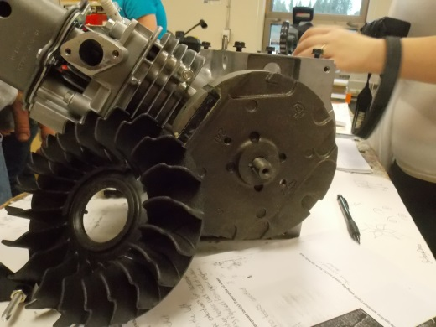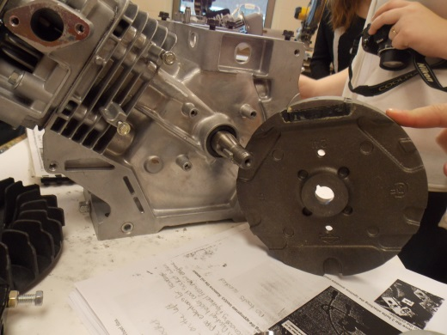
- Remove the 4 bolts from the OHV valve cover using a 10mm wrench or socket. Note the symbols on the top of the bolts and their position; brass bolt goes on the bottom. Note the position of the gasket between the cover and the cylinder head. Screw the 4 bolts back into the cylinder head.
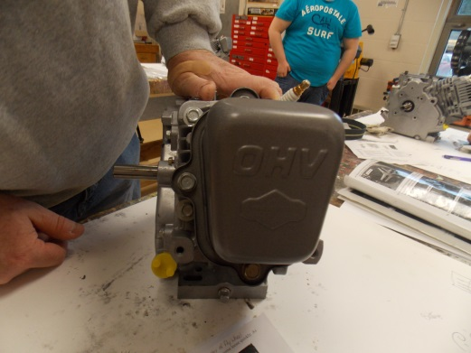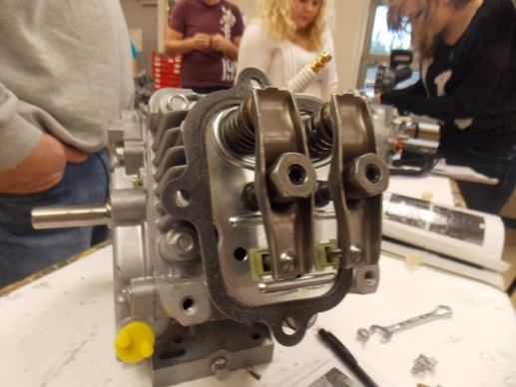
- Remove the 4 cylinder head bolts using the 10mm socket or wrench.
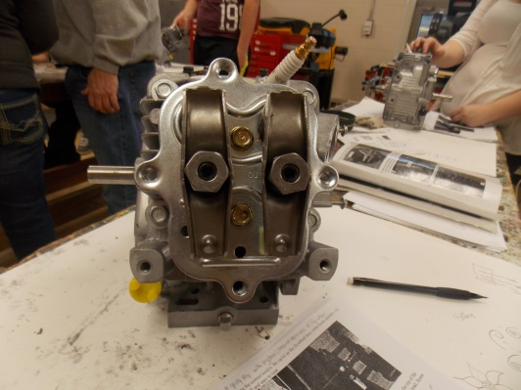
- Very carefully remove the cylinder head being careful not to bend the valve push rods and to not lose the caps under the rocker arms on the ends of the valve stems. Note the position of the gasket between the cylinder head and the cylinder. Remove the valve push rods and screw the 4 bolts back into the cylinder head. Place the engine block on newspaper. Remove spark plug with 5/8 socket.
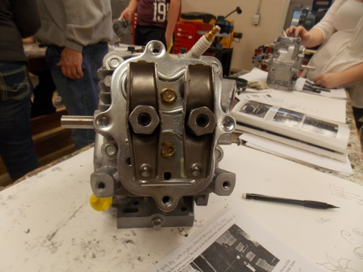
- Remove the 6 bolts from the crankcase cover using 10mm wrench or socket.
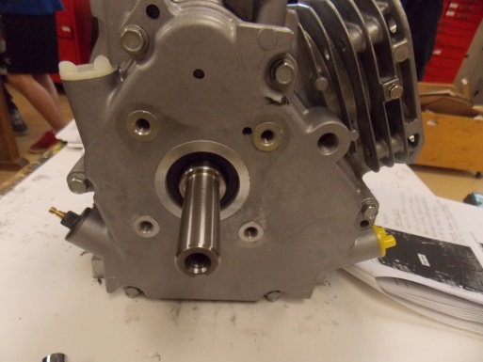
- VERY carefully remove the crankcase cover taking great care not to damage the gasket between the cover and the crankcase. If there is any oil still in the crankcase/base it will leak out. Note the position of the oil level sensor, the oil-slinger assembly and the bearing on the inside of the crankcase cover. Screw the 6 bolts back into the crankcase. Remove the push rod holders.
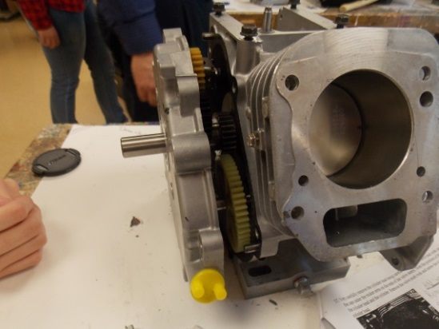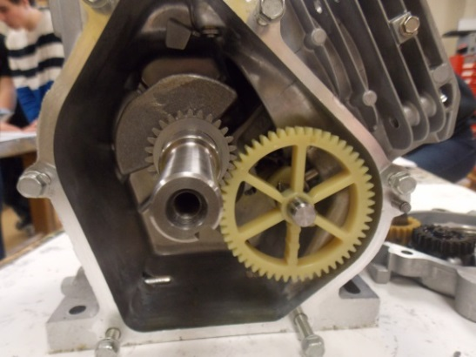
- Rotate the crankshaft until you can carefully remove the camshaft. Note the large plastic gear and the two plastic cams located on the camshaft. Remove the 2 valve lifters. Look inside the crankcase and located the oil dipper, crankshaft, connecting rod cover. No tools are needed, pull lifters out with fingers.
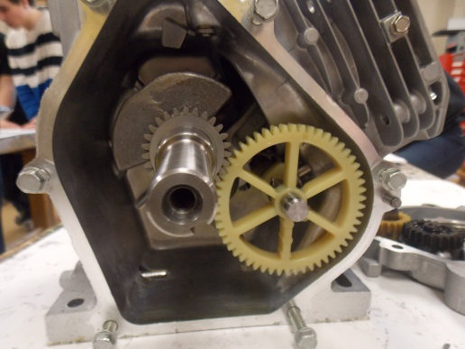
- Remove the 2 bolts attaching the connecting rod cap and the oil dipper to the connecting rod using an 8mm wrench or socket. Remove the connecting rod cap, noting the way that the cap attaches to the connecting rod. Also note the position of the crankshaft and the connecting rod.
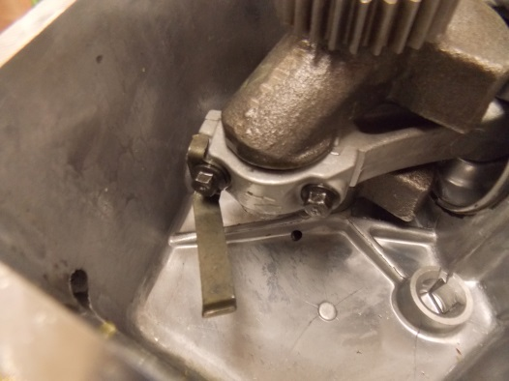
- Turn the crankshaft until the piston reaches TDC. Note the numbers etched into the top of the piston and the location of the notch in the piston relative to the side of the engine (flywheel side).
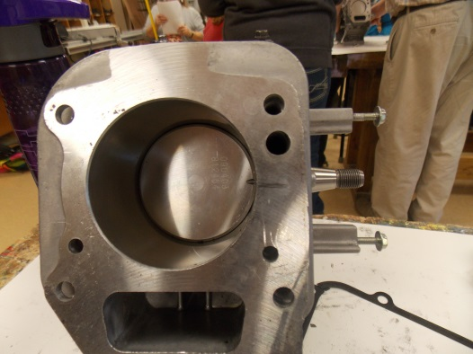
- Push the piston out of the cylinder. Note the number of piston rings and their position. The number is stamped into the connecting rod.
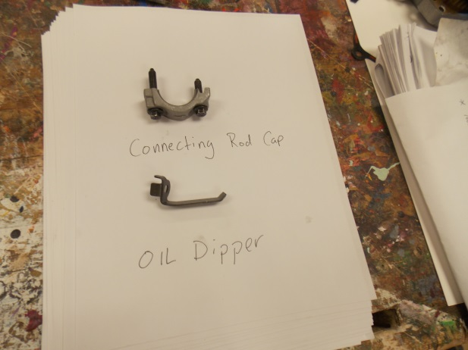
- Carefully remove the crankshaft and the crankshaft gear and spacer.
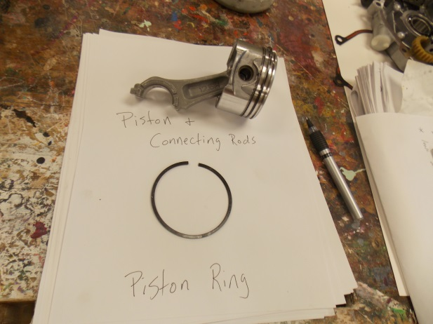
- Remove the crankshaft gear and spacer from the crankshaft noting the order in which both are removed and the location of the indentation on the gear relative to the side of the engine.
